Phase 3: Data Modeling & Relationships
- 1. Standard & Custom Objects
in the Loan Origination process, we need to store data for applicants, their loan applications, and related information. While Salesforce provides standard objects like Account, Contact, and User, we create Custom Objects to manage loan-specific data.

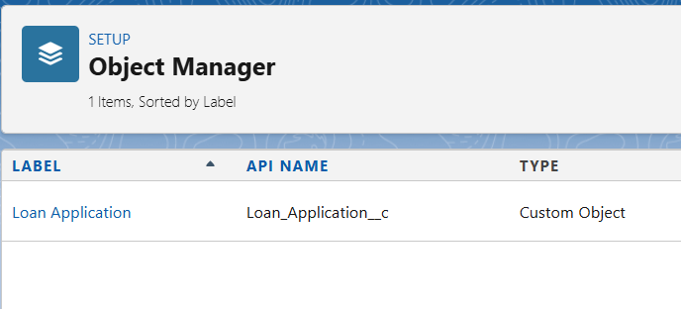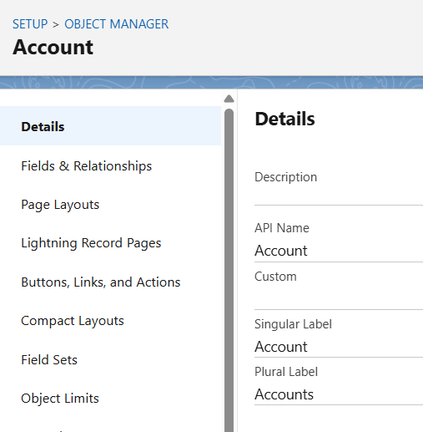

- Fields
Each custom object contains specific fields needed to capture data for that entity.

Example: Loan_Application__c Fields
Field Label | API Name | Data Type | Description
Applicant Name | Applicant_Name__c | Text | Name of the loan applicant
Loan Type | Loan_Type__c | Picklist | Type of loan (Home, Car, Personal)
Loan Amount | Loan_Amount__c | Currency | Total amount requested
Income | Income__c | Currency | Applicant’s monthly income
Loan Status | Loan_Status__c | Picklist | Tracks loan stage (Submitted, Approved, Rejected)
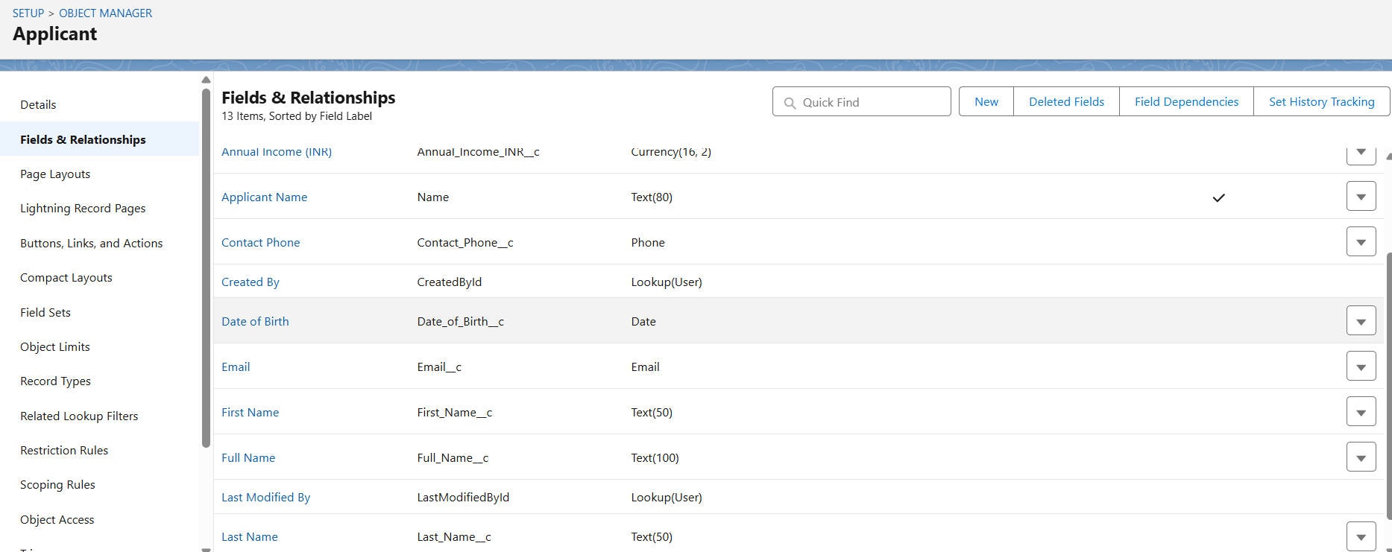

- Record Types
🔹 Use Case:
Different loan types require different page layouts or processes.
Hence, we create Record Types for:
- Home Loan
- Car Loan
- Personal Loan
This allows different fields or sections to appear based on loan type.
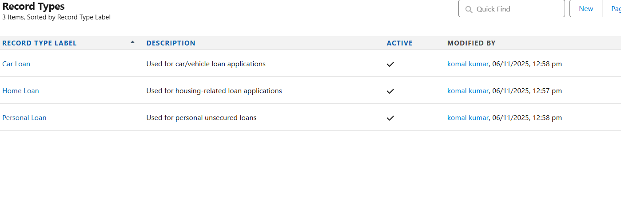
- Page Layouts
🔹 Use Case:
Each record type uses a unique page layout that displays relevant fields and sections.
For example:
- Home Loan Layout: includes Property Details
- Car Loan Layout: includes Vehicle Information
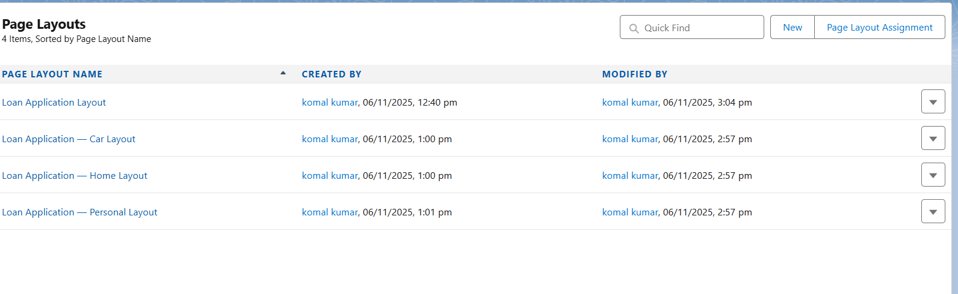
- Lookup vs Master-Detail vs Hierarchical Relationship
Relationship Type | Example | Description
Lookup | Loan Application → Contact | Links loan record to the applicant but doesn’t depend on parent record.
Master-Detail | EMI_Detail → Loan_Application | EMI details are deleted if the parent loan record is deleted.
Hierarchical | User → Manager | Used only for User object to show reporting structure.

This phase established the data model backbone of the Banking Loan Origination System.
All entities — Applicants, Loans, Documents, and EMIs — are connected through relationships that support end-to-end tracking and reporting.

